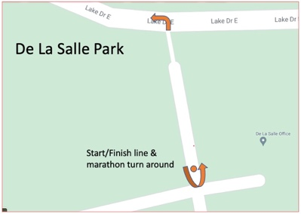
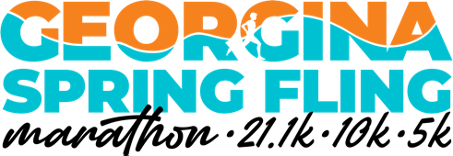
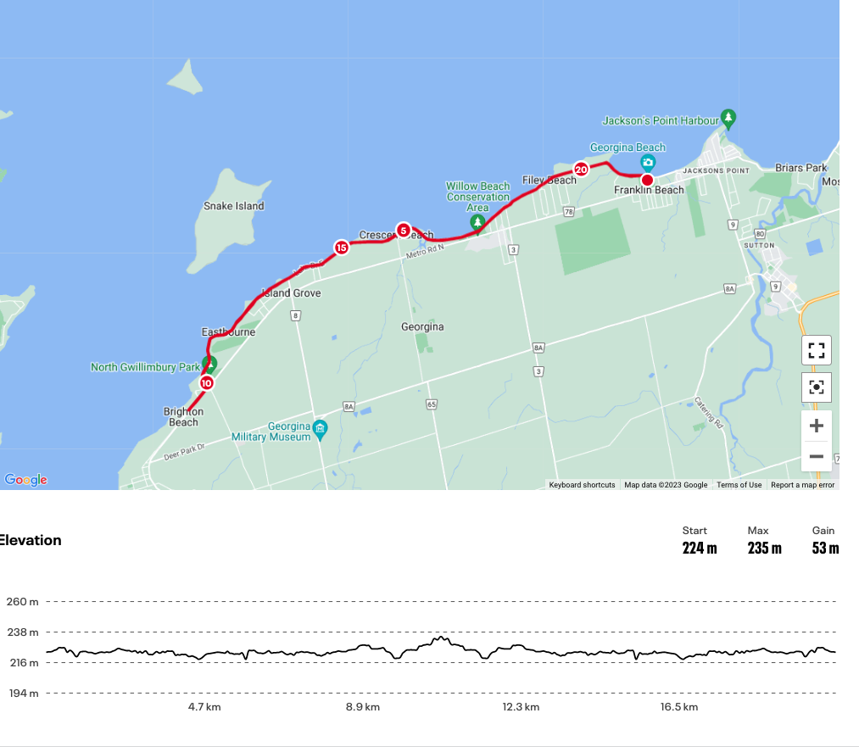
Sunday, May 3, 20246
Start/Finish in De La Salle Park - Marathon – 2 loops; Half-Marathon- 1 loop

